Digital Logic Design Laboratory

Lab 1

Introduction Simulation Software and Logic Gates

Full name: Phan Tiến Đạt

Student number: EEACIU22170

Class: ……………………………………………….......

Date: …………………………………………………....

# I. Objectives

In this laboratory, students will study:

- Familiar with simulation software

- Understand the operation of logic gates.

- Build a combination circuit that implements a Boolean expression.

- Use IC designing circuit which is satisfied the below truth table.

# II. Procedure

1. Investigate Logic Gates

Investigate the basic logic gates by using simulation software

a. NOT gate

- One input of NOT gate wire up to switch.

- Output wire up to led-display

- Toggle switch to change input logic level.

- Get the results and write down the truth table of NOT gate.

|  |  |
| --- | --- |
| A | Y= |
| Low | 1 |
| High | 0 |

Implement the circuit via simulation software and paste the result in here

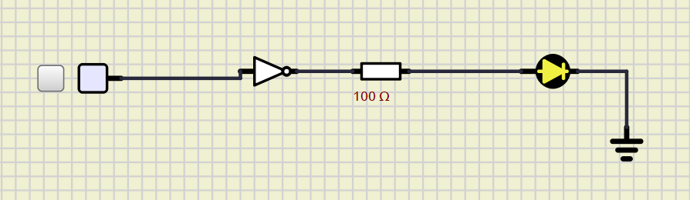

b. AND gate

- Two inputs of AND gate wire up to switches.

- Output wire up to led-display

- Toggle switch to change input logic level.

- Get the results and write down the truth table of AND gate.

|  |  |  |
| --- | --- | --- |
| A | B | Y= AB |
| Low | Low | 0 |
| Low | High | 0 |
| High | Low | 0 |
| High | High | 1 |

Implement the circuit via simulation software and paste the result in here

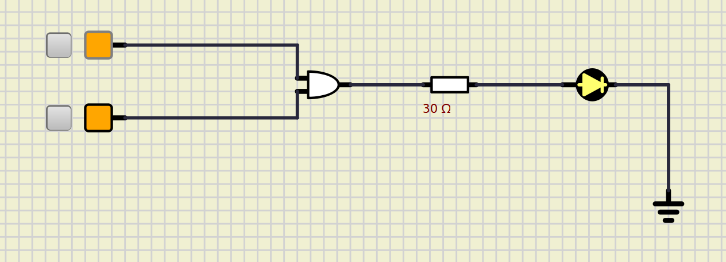

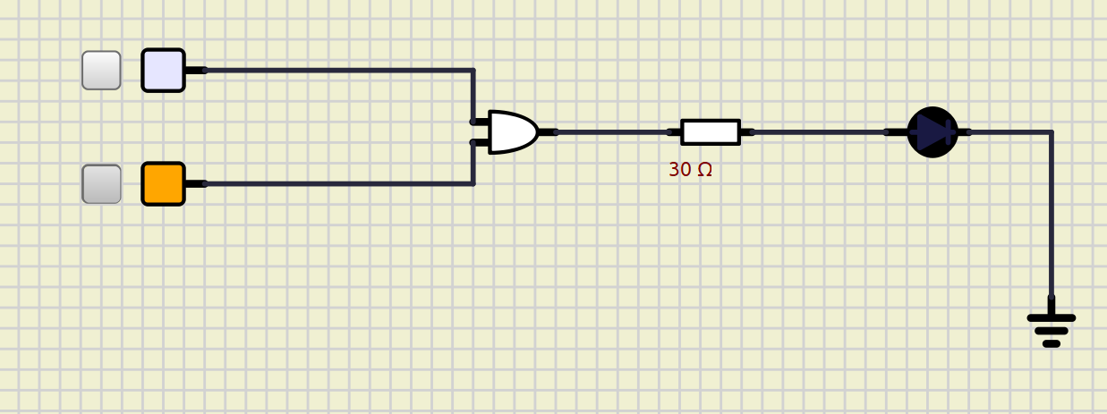

c. OR gate

- Two inputs of OR gate wire up to switches.

- Output wire up to led-display

- Toggle switch to change input logic level.

- Get the results and write down the truth table of OR gate.

|  |  |  |
| --- | --- | --- |
| A | B | Y= A+B |
| Low | Low | 0 |
| Low | High | 1 |
| High | Low | 1 |
| High | High | 1 |

Implement the circuit via simulation software and paste the result in here

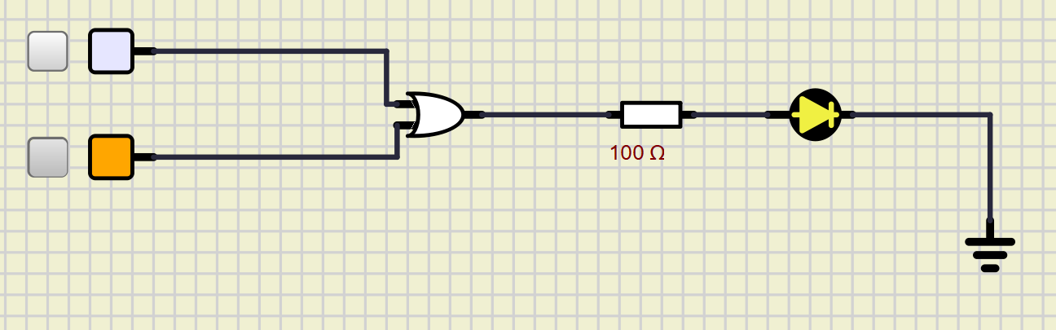

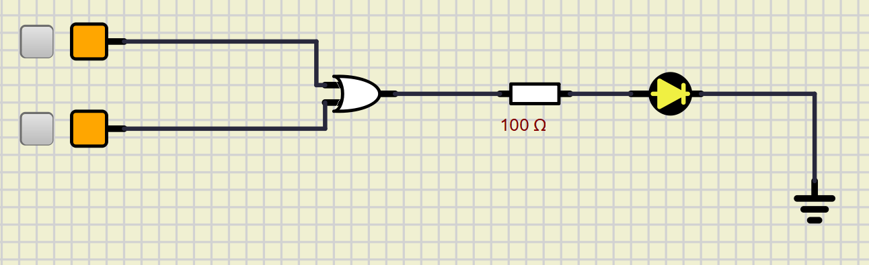

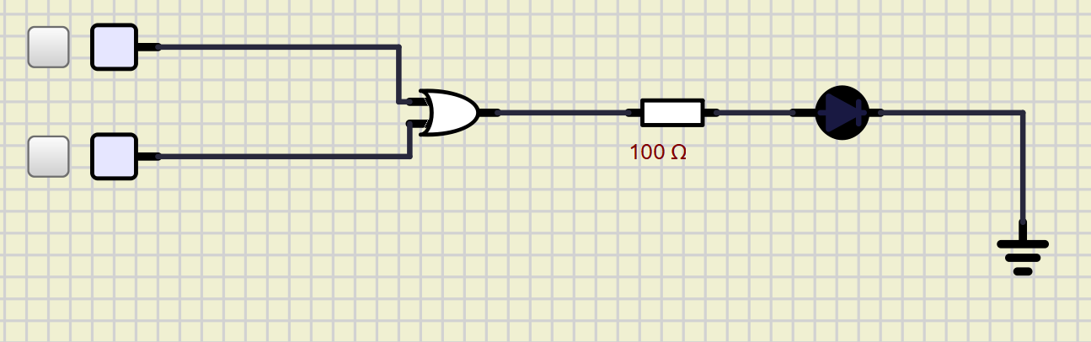

d. XOR gate

- Two inputs of XOR gate wire up to switches.

- Output wire up to led-display

- Toggle switch to change input logic level.

- Get the results and write down the truth table of XOR gate.

|  |  |  |
| --- | --- | --- |
| A | B | Y= AB |
| Low | Low | 0 |
| Low | High | 1 |
| High | Low | 1 |
| High | High | 0 |

Implement the circuit via simulation software and paste the result in here

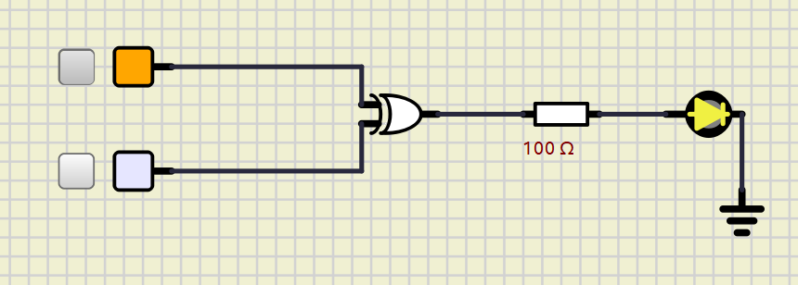

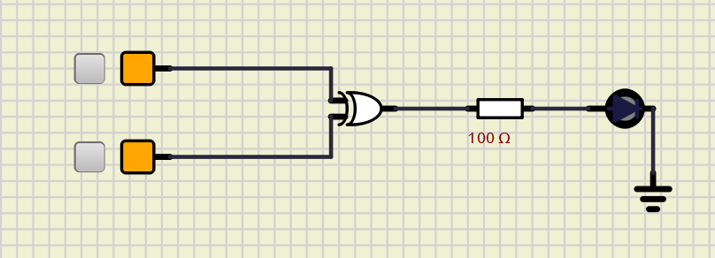

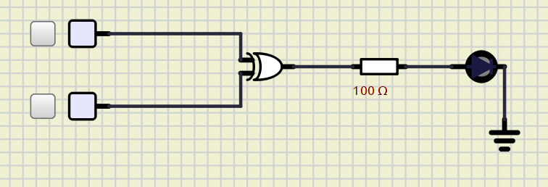

e. NAND gate

- Two inputs of NAND gate wire up to switches.

- Output wire up to led-display

- Toggle switch to change input logic level.

- Get the results and write down the truth table of NAND gate.

|  |  |  |
| --- | --- | --- |
| A | B | Y= |
| Low | Low | 1 |
| Low | High | 1 |
| High | Low | 1 |
| High | High | 0 |

Implement the circuit via simulation software and paste the result in here

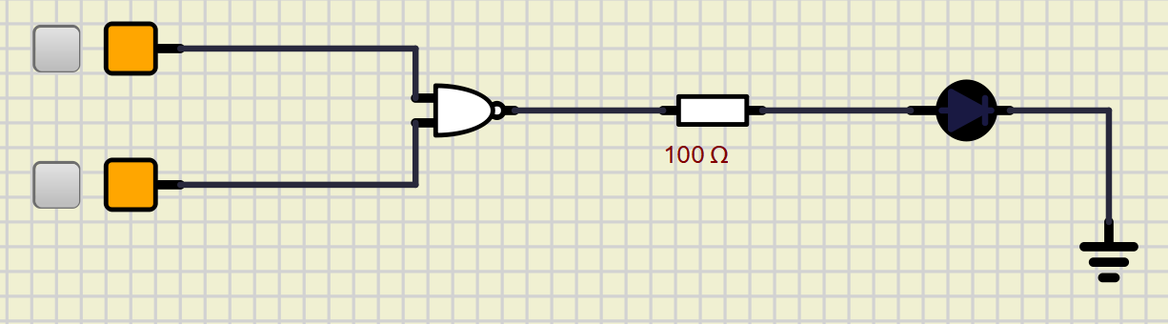

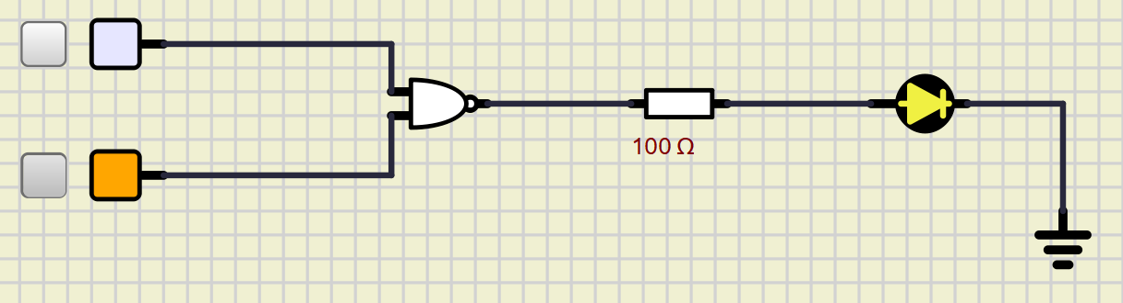

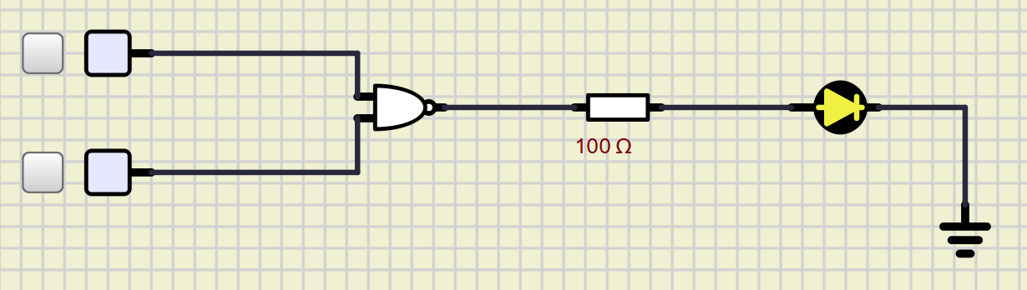

f. NOR gate

- Two inputs of NOR gate wire up to switches.

- Output wire up to led-display

- Toggle switch to change input logic level.

- Get the results and write down the truth table of NOR gate.

|  |  |  |
| --- | --- | --- |
| A | B | Y= |
| Low | Low | 1 |
| Low | High | 0 |
| High | Low | 0 |
| High | High | 0 |

Implement the circuit via simulation software and paste the result in here

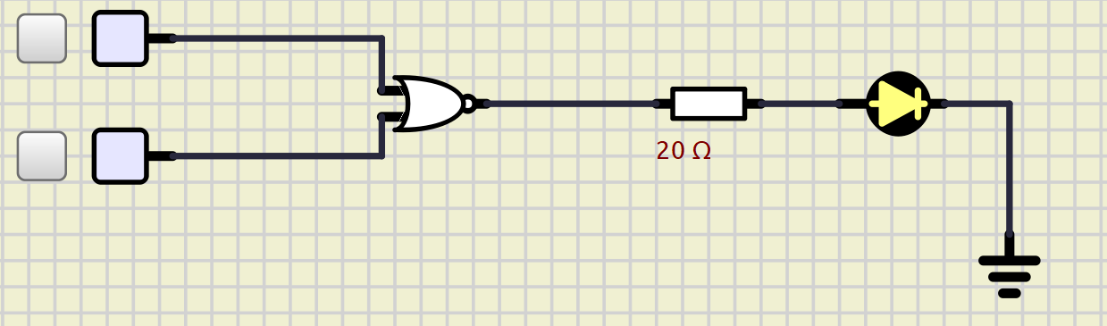

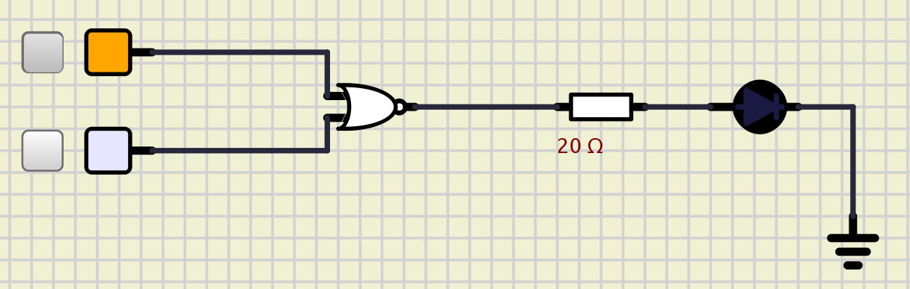



2. Changing gate method

Using universal gate (NAND & NOR gate) to derive other logic gates

a. Using NAND to make other logic gates

- Construct the circuit for each figure 1

- Output wire up to led-display

- Toggle switch to change input logic level.

- Get the results and write down the truth table of figure 1a.

- Do the same steps for figure 1b, 1c, 1d.



Figure 1a

Figure 1b

Figure 1c

Figure 1d

- Which do these circuits in figure 1a, 1b, 1c, 1d correspond with logic gates?

Truth table and correspond with logic gates of Figure 1b

|  |  |  |
| --- | --- | --- |
| A | B | Y (Output) |
| 0 | 0 | 0 |
| 0 | 1 | 0 |
| 1 | 0 | 0 |
| 1 | 1 | 1 |

Implement the circuit via simulation software and paste the result in here

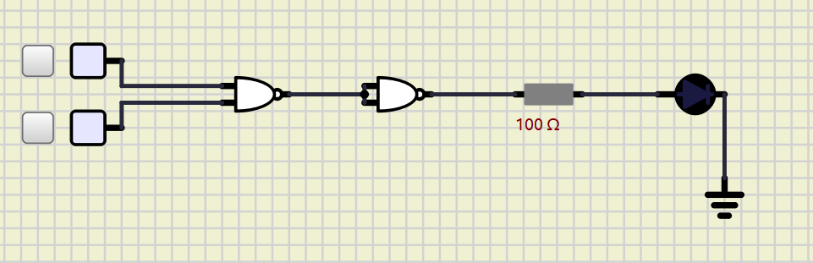

Truth table and correspond with logic gates of Figure 1c

|  |  |  |
| --- | --- | --- |
| A | B | Y (Output) |
| 0 | 0 | 0 |
| 0 | 1 | 1 |
| 1 | 0 | 1 |
| 1 | 1 | 1 |

Implement the circuit via simulation software and paste the result in here

Truth table and correspond with logic gates of Figure 1d

|  |  |  |
| --- | --- | --- |
| A | B | Y (Output) |
| 0 | 0 | 1 |
| 0 | 1 | 0 |
| 1 | 0 | 0 |
| 1 | 1 | 0 |

Implement the circuit via simulation software and paste the result in here



b. Using NOR to make other logic gates

- Construct the circuit for each figure 2

- Output wire up to led-display

- Toggle switch to change input logic level.

- Get the results and write down the truth table of figure2a.

- Do the same steps for figure 2b, 2c, 2d.



Figure 2a

Figure 2b

Figure 2c

Figure 2d

- Which do these circuits in figure 2a, 2b, 2c, 2d correspond with logic gates?

Truth table and correspond with logic gates of Figure 2b

|  |  |  |
| --- | --- | --- |
| A | B | Y (Output) |
| 0 | 0 | 0 |
| 0 | 1 | 1 |
| 1 | 0 | 1 |
| 1 | 1 | 1 |

Implement the circuit via simulation software and paste the result in here

Truth table and correspond with logic gates of Figure 2c

|  |  |  |
| --- | --- | --- |
| A | B | Y (Output) |
| 0 | 0 | 0 |
| 0 | 1 | 0 |
| 1 | 0 | 0 |
| 1 | 1 | 1 |

Implement the circuit via simulation software and paste the result in here

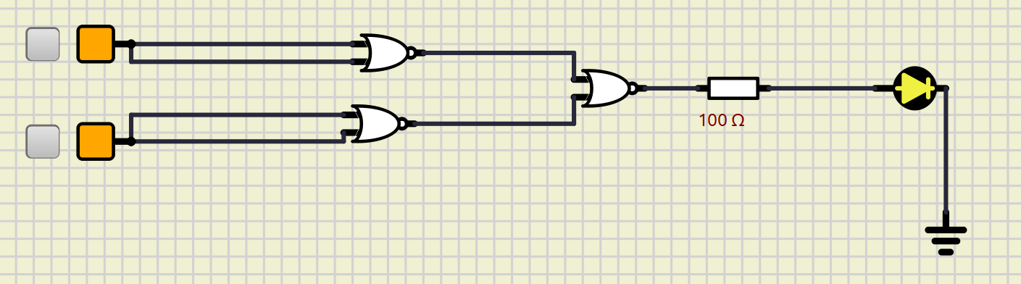

Truth table and correspond with logic gates of Figure 2d

|  |  |  |
| --- | --- | --- |
| A | B | Y (Output) |
| 0 | 0 | 1 |
| 0 | 1 | 1 |
| 1 | 0 | 1 |
| 1 | 1 | 0 |

Implement the circuit via simulation software and paste the result in here

3. Design and simply the combinational logic circuit using logic gates

a. Given the circuit below, find the function

Write down the function

Fill in the truth Table:

|  |  |  |  |
| --- | --- | --- | --- |
| A | B | C | F1 |
| 0 | 0 | 0 | 0 |
| 0 | 0 | 1 | 1 |
| 0 | 1 | 0 | 1 |
| 0 | 1 | 1 | 1 |
| 1 | 0 | 0 | 0 |
| 1 | 0 | 1 | 1 |
| 1 | 1 | 0 | 0 |
| 1 | 1 | 1 | 1 |

Implement the circuit via simulation software and paste the result in here

Using K-map to simplify function above

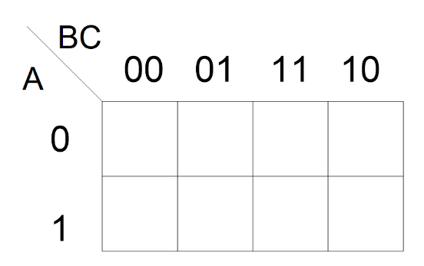

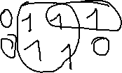

The simplified C +

Implement the new expression via simulation software and paste the result in here

b. Given the circuit below, find the function

Write down the function

PoS =

K-map :

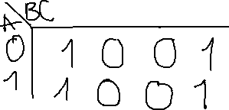

Fill in the truth Table:

|  |  |  |  |
| --- | --- | --- | --- |
| A | B | C | F2 |
| 0 | 0 | 0 | 1 |
| 0 | 0 | 1 | 0 |
| 0 | 1 | 0 | 1 |
| 0 | 1 | 1 | 0 |
| 1 | 0 | 0 | 1 |
| 1 | 0 | 1 | 0 |
| 1 | 1 | 0 | 1 |
| 1 | 1 | 1 | 0 |
|  |  |  |  |

Implement the circuit via simulation software and paste the result in here

Using K-map to simplify function above



The simplified

Implement the new expression via simulation software and paste the result in here

c. Given the circuit below, find the function

Write down the function

SoP =

PoS = ((

Simplify by K-map:

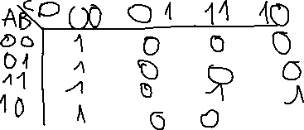

Fill in the truth Table:

|  |  |  |  |  |
| --- | --- | --- | --- | --- |
| A | B | C | D | F3 |
| 0 | 0 | 0 | 0 | 1 |
| 0 | 0 | 0 | 1 | 0 |
| 0 | 0 | 1 | 0 | 0 |
| 0 | 0 | 1 | 1 | 0 |
| 0 | 1 | 0 | 0 | 1 |
| 0 | 1 | 0 | 1 | 0 |
| 0 | 1 | 1 | 0 | 0 |
| 0 | 1 | 1 | 1 | 0 |
| 1 | 0 | 0 | 0 | 1 |
| 1 | 0 | 0 | 1 | 0 |
| 1 | 0 | 1 | 0 | 0 |
| 1 | 0 | 1 | 1 | 0 |
| 1 | 1 | 0 | 0 | 1 |
| 1 | 1 | 0 | 1 | 0 |
| 1 | 1 | 1 | 0 | 1 |
| 1 | 1 | 1 | 1 | 1 |

Implement the circuit via simulation software and paste the result in here

Using K-map to simplify function above

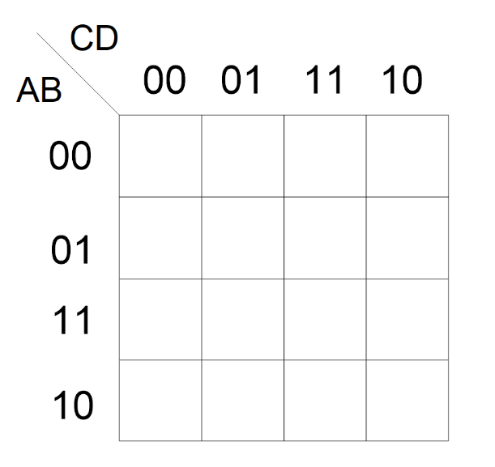

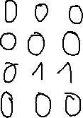

The simplified

Implement the new expression via simulation software and paste the result in here

4. Design and simply the combinational logic circuit using IC logic gates

- Building the circuit from the Integrated Circuits (IC).

IC 74HC00 is quad input NAND gate and 74HC02 is quad input NOR gate

a. Only Using NAND gates in IC 74HC00 to construct the circuit for expression

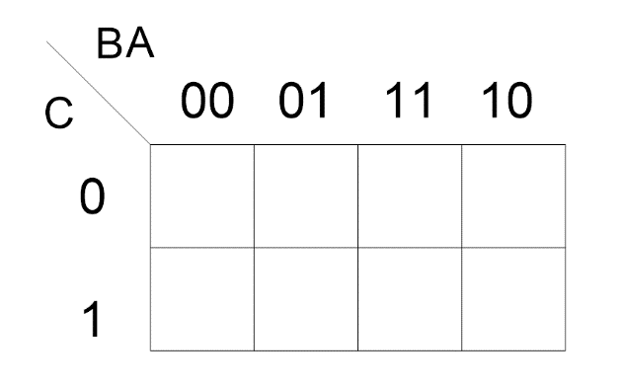

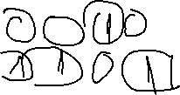

The simplified expression is

Implement the circuit via simulation software and paste the result in here

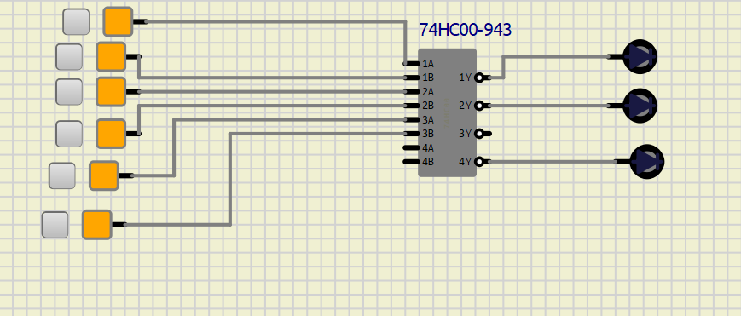

b. Only Using NOR gates in IC 74HC02 to construct the circuit for expression

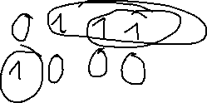

The simplified expression is

Implement the circuit via simulation software and paste the result in here

Extra Exercise

Besides the IC 74HC00 for NAND gates and 74HC02 for NOR gates, there are also IC for AND, OR, XOR gates:

+ 74HC08 quad 2-input AND gate

+ 74HC32 quad 2-input OR gate

+ 74HC86 quad 2-input XOR gate

Implement the circuit below by using the IC above in simulation software

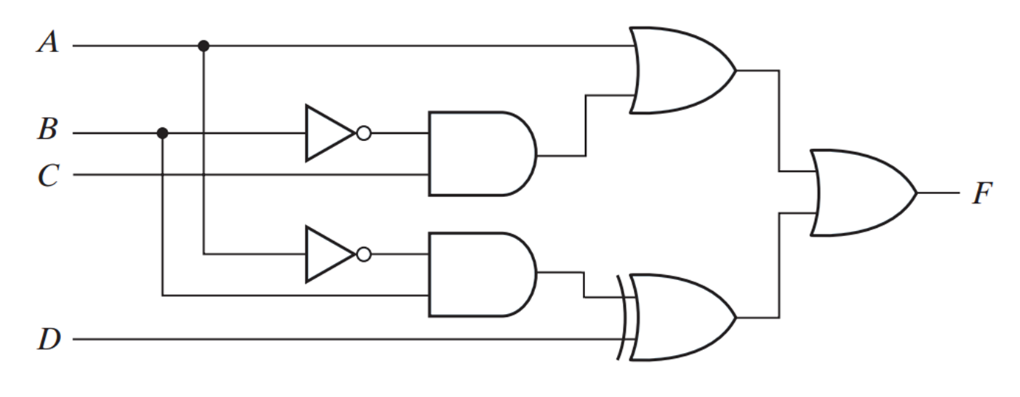

Paste the result from simulation software in here

The expression for the circuit is

Is the expression is simplest or not? If not, provide your simplification step and implement the simplified circuit in simulation software.